

| **Title: Implementation of All Pair Shortest Path using Dynamic Programming** |
| --- |

**Objective** To learn the All-Pair Shortest Path using Floyd-Warshall’salgorithm

**CO to be achieved:**

| CO 2 | Describe various algorithm design strategies to solve different problems and analyse Complexity. |
| --- | --- |

**Books/ Journals/ Websites referred:**

1. **Ellis horowitz, Sarataj Sahni, S.Rajsekaran,” Fundamentals of computer algorithm”, University Press**
2. **T.H.Cormen ,C.E.Leiserson,R.L.Rivest and C.Stein,” Introduction to algortihtms”,2nd Edition ,MIT press/McGraw Hill,2001**
3. **http://users.cecs.anu.edu.au/~Alistair.Rendell/Teaching/apac_comp3600/module4/all_pairs_shortest_paths.xhtml**
4. **https://www.geeksforgeeks.org/floyd-warshall-algorithm-dp-16/**
5. **http://www.cs.bilkent.edu.tr/~atat/502/AllPairsSP.ppt**

**Theory:**

It aims to figure out the shortest path from each vertex v to every other u.

1. In all pair shortest path, when a weighted graph is represented by its weight matrix W then objective is to find the distance between every pair of nodes.
2. Apply dynamic programming to solve the all pairs shortest path.
3. In all pair shortest path algorithm, we first decomposed the given problem into sub problems.
4. In this principle of optimally is used for solving the problem.
5. It means any sub path of shortest path is a shortest path between the end nodes.

**Algorithm:**

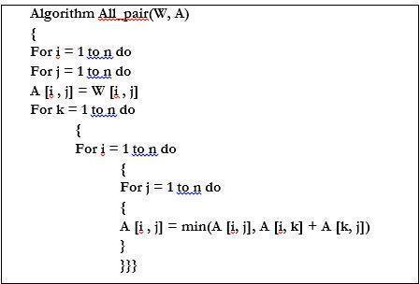

**Example :** 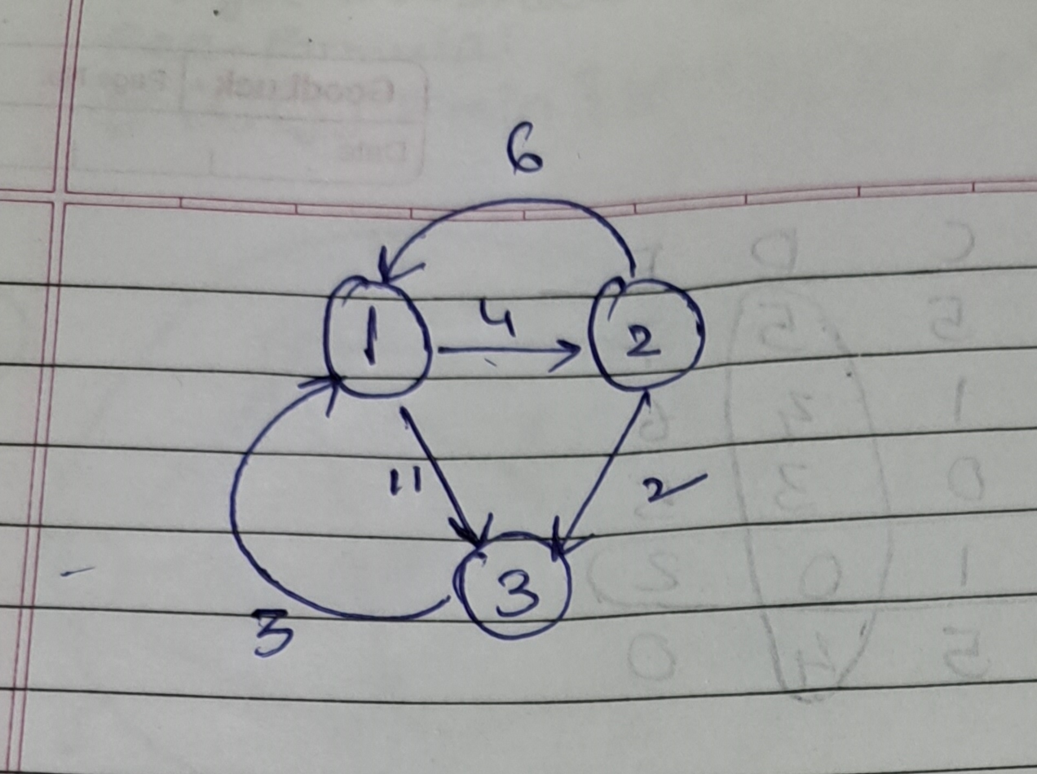

**Solution for the example:**

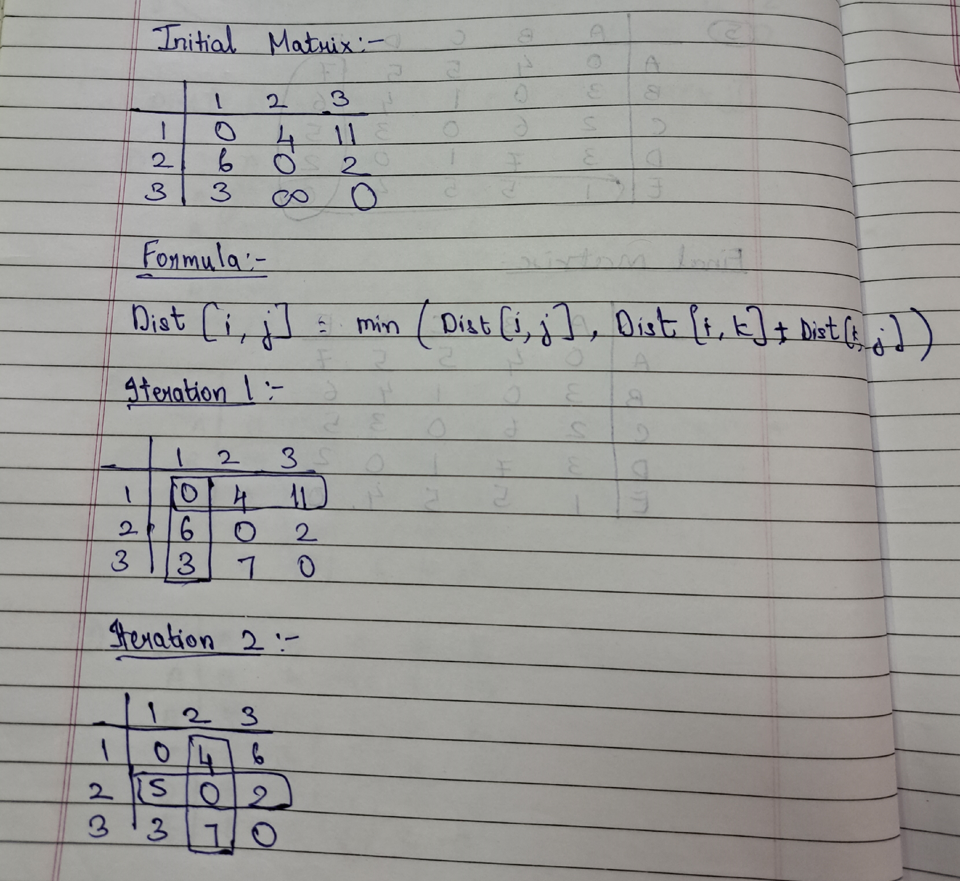

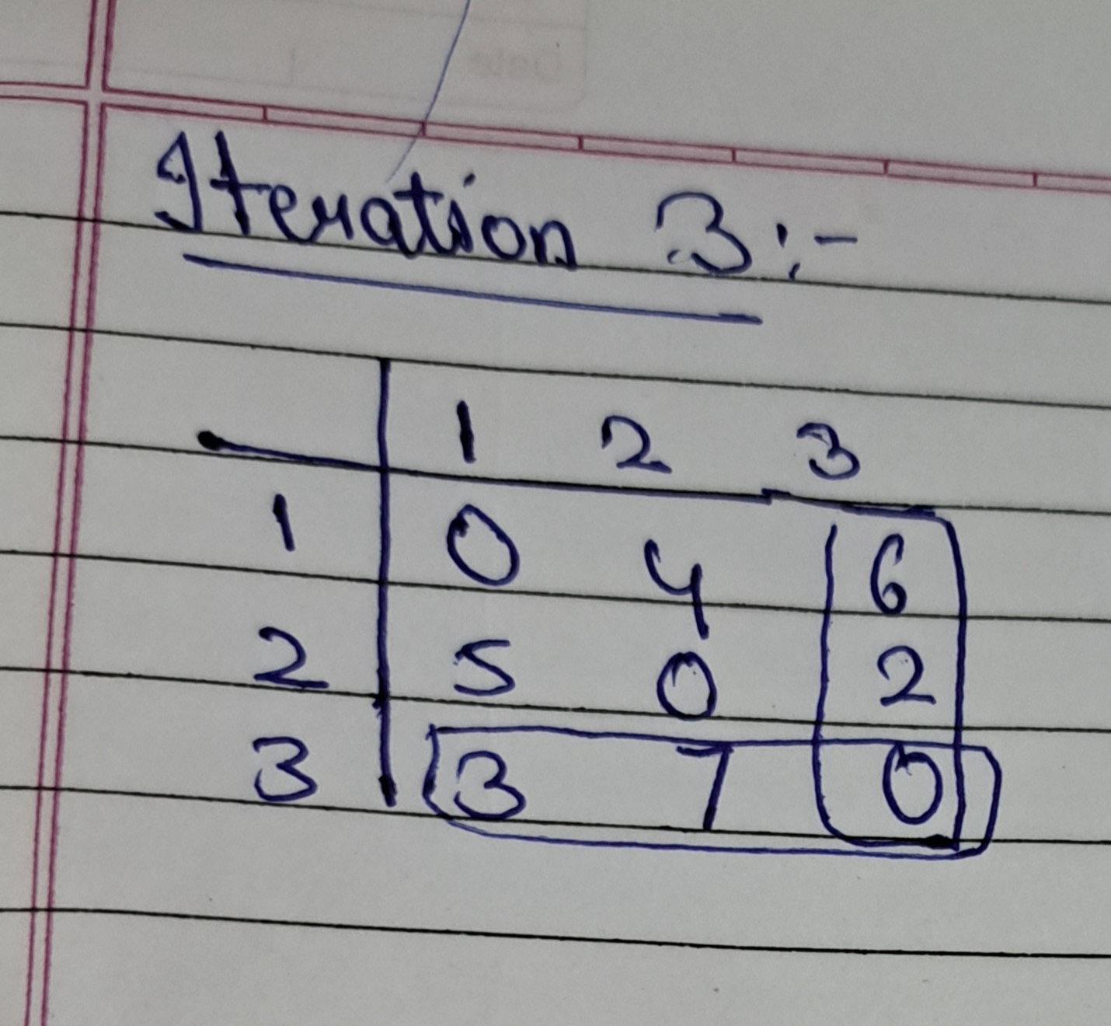

**CODE:**

#include <iostream>

#include <vector>

#include <limits>

#include <iomanip>

using namespace std;

const int INF = numeric_limits<int>::max() / 2;

void floydWarshall(vector<vector<int>> &dist, int n) {

for (int k = 0; k < n; k++) {

for (int i = 0; i < n; i++) {

for (int j = 0; j < n; j++) {

if (dist[i][k] != INF && dist[k][j] != INF && dist[i][k] + dist[k][j] < dist[i][j])

dist[i][j] = dist[i][k] + dist[k][j];

}

}

}

}

void printSolution(vector<vector<int>> &dist, vector<char> &vertices) {

cout << " ";

for (char vertex : vertices) {

cout << setw(3) << vertex << " ";

}

cout << endl;

for (int i = 0; i < dist.size(); i++) {

cout << setw(3) << vertices[i] << " ";

for (int j = 0; j < dist[i].size(); j++) {

cout << setw(3);

if (dist[i][j] == INF)

cout << "INF ";

else

cout << dist[i][j] << " ";

}

cout << endl;

}

}

int main() {

vector<char> vertices = {'A', 'K', 'S', 'H', 'A', 'T'};

int n = vertices.size();

vector<vector<int>> graph = {

{0, 5, 2, 7, INF, 10},

{INF, 0, 4, 3, 4, INF},

{INF, INF, 0, INF, INF, 1},

{INF, INF, 2, 0, 3, INF},

{8, INF, 5, INF, 0, INF},

{INF, INF, INF, INF, INF, 0}

};

vector<vector<int>> dist = graph;

floydWarshall(dist, n);

cout << " AKSHAT 221" << endl;

cout << " All Pairs Shortest Paths:" << endl;

printSolution(dist, vertices);

return 0;

}

**OUTPUT:**

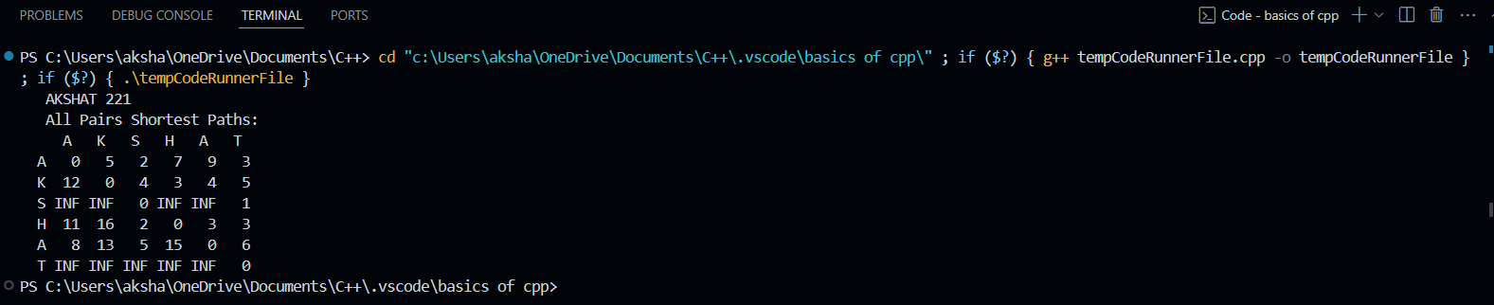

**Analysis of algorithm:**

**Time Complexity: O(V^3)**

**Space Complexity: O(V^2)**

**CONCLUSION:**

The Floyd-Warshall algorithm is an efficient dynamic programming approach to find

the shortest path between all pairs of vertices in a weighted graph. By implementing it

in C++, I likely gained experience with dynamic programming, handling 2D arrays or

matrices, and optimizing nested loop structures. The algorithm's time complexity is

O(n^3), making it suitable for dense graphs with a reasonable number of vertices.

Overall, it's a valuable algorithm for understanding graph theory and developing

efficient solutions for the all-pairs shortest path problem.